**Day 3**

Node -> Its is like an VM where all our code will be execute it’s kind of like System (Slave)

Global Security -> It is used for the security purpose of Jenkins

**Deployment of Full Stack Java Application with Docker**

First clone the Java Application repository which we are going to use in this project

Java Application GitHub Link: <https://github.com/Christober-S/Ekart.git>

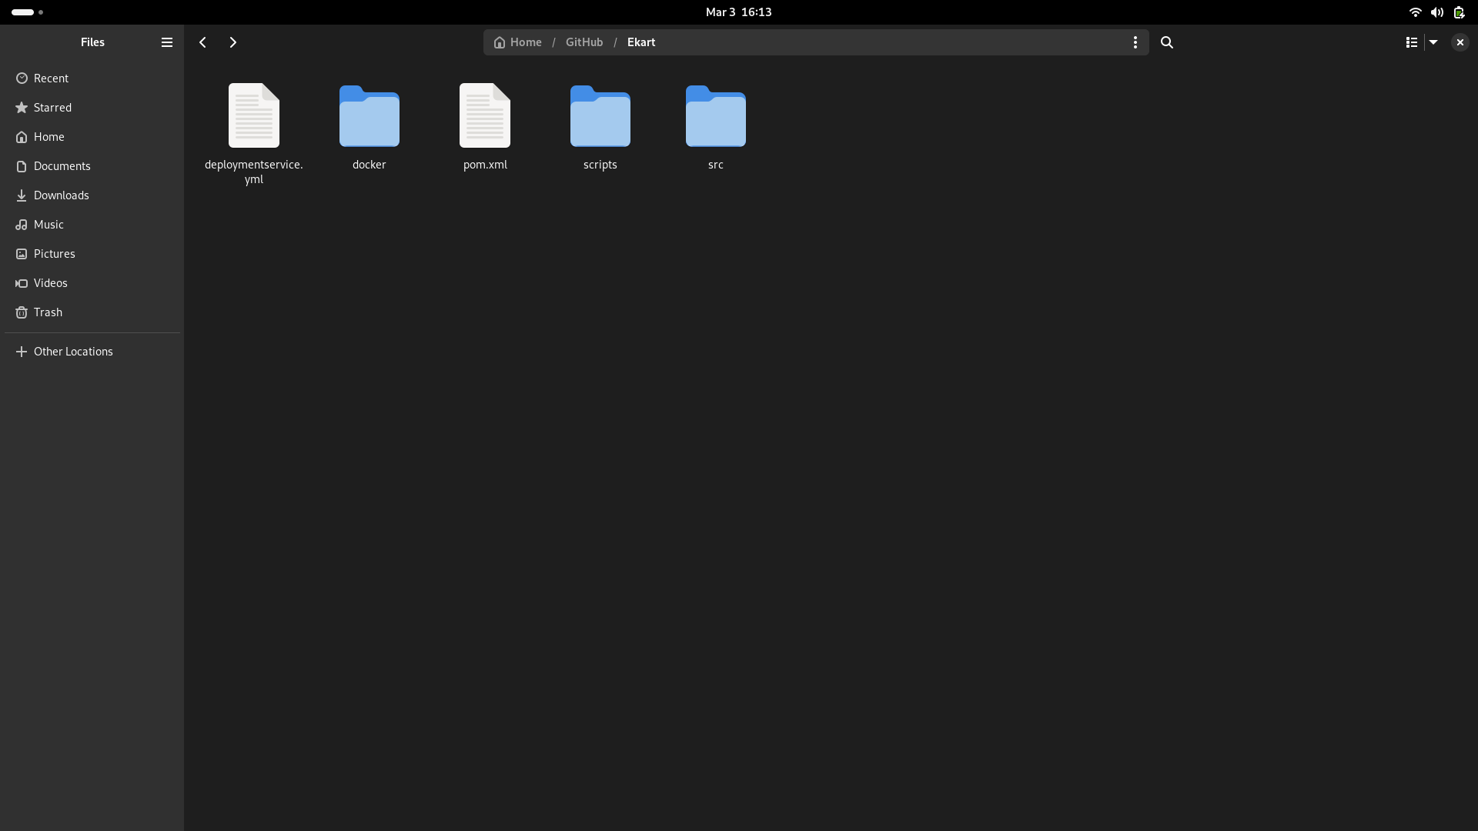

We have download Java & Maven

Commands to download those:

Sudo dnf update

Sudo dnf install openjdk-11-jre -y

Sudo dnf install maven -y

After cloning the repo,

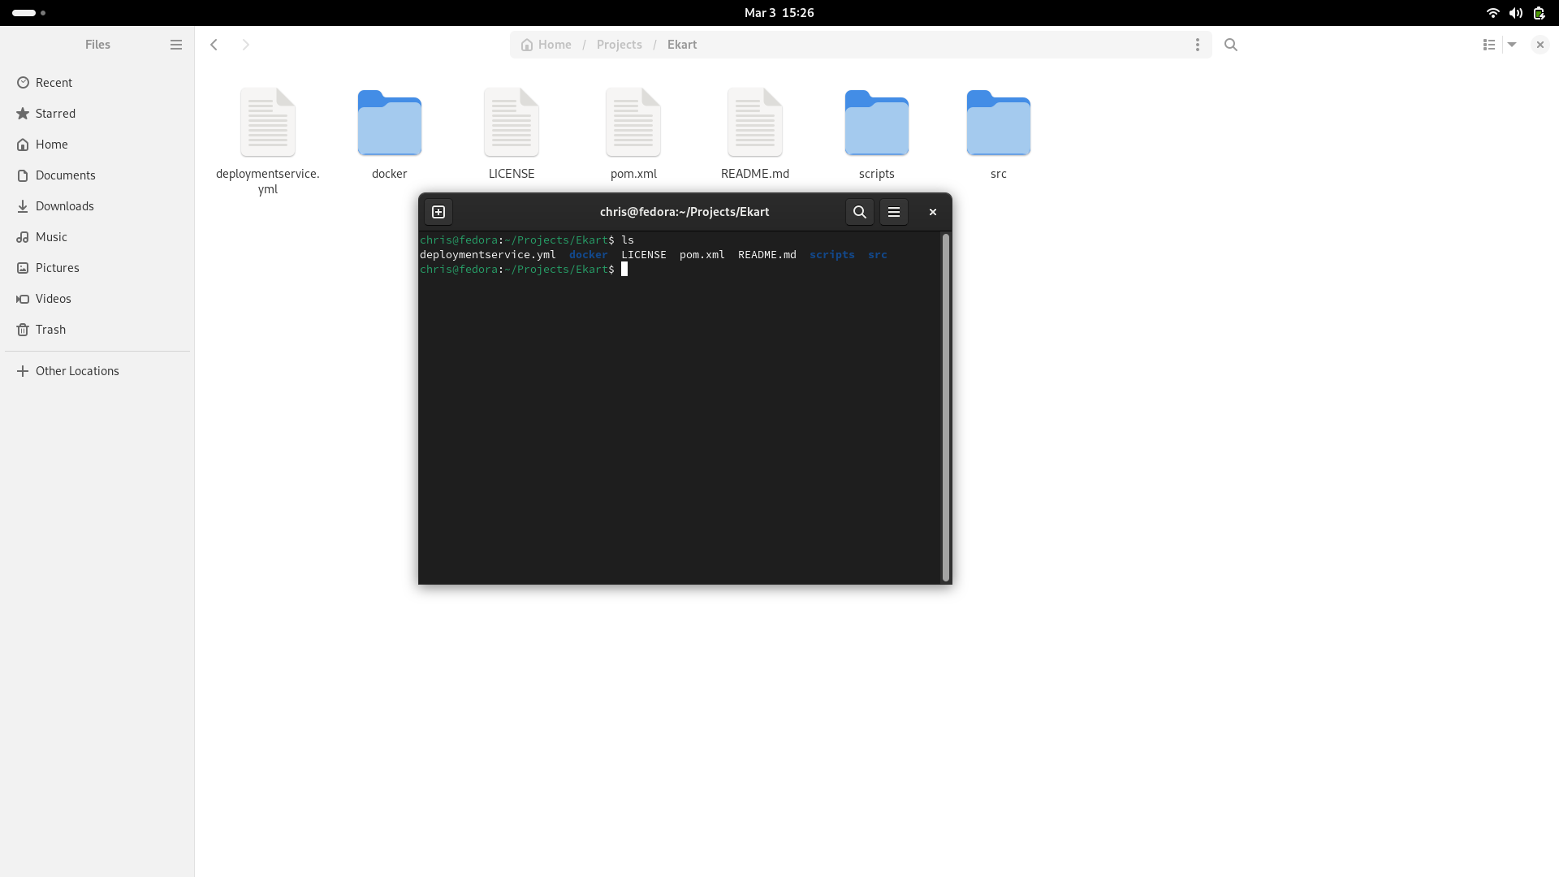

We have build the project to generate Jar file

Command to build artifiact using maven

Cmd: mvn clean package -DskipTests=true

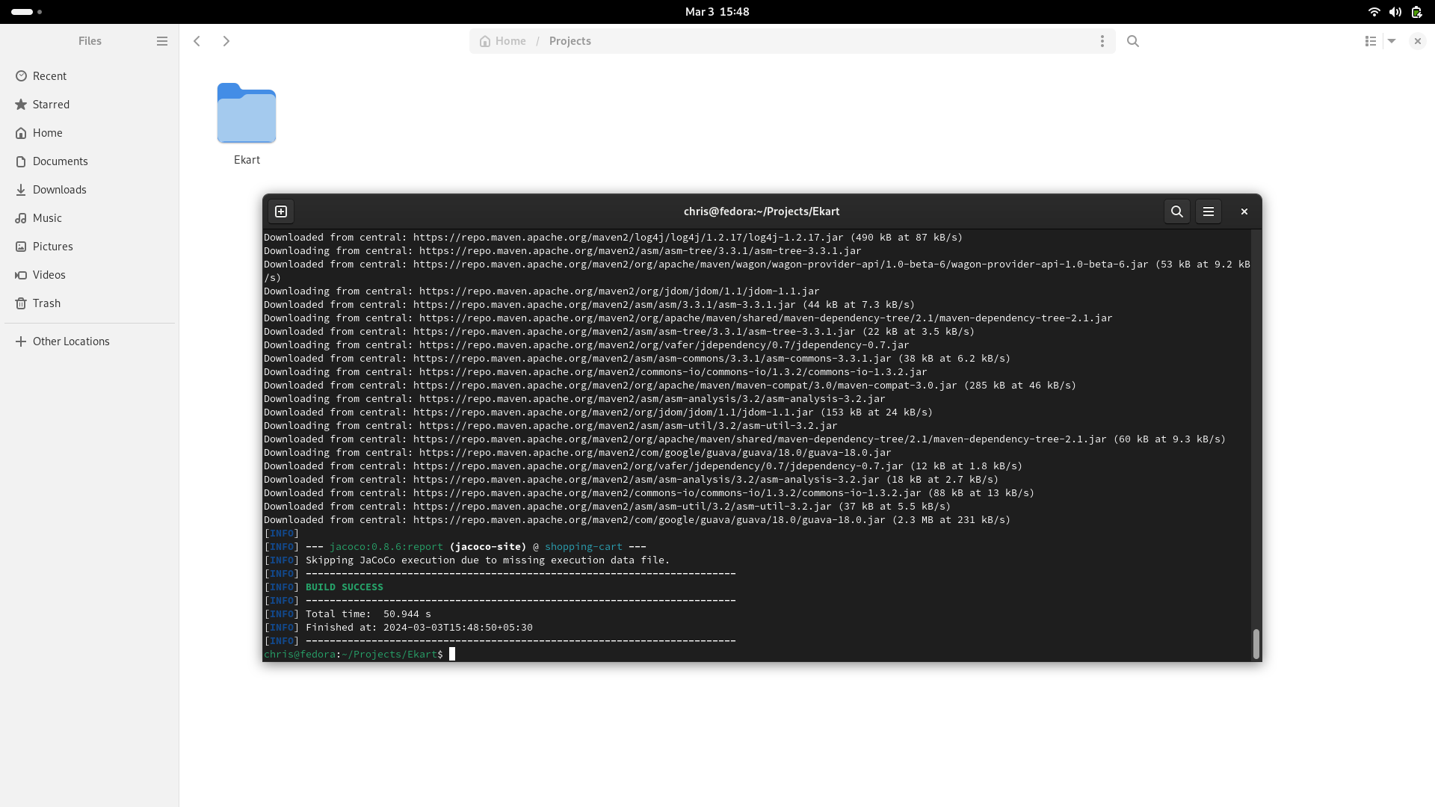

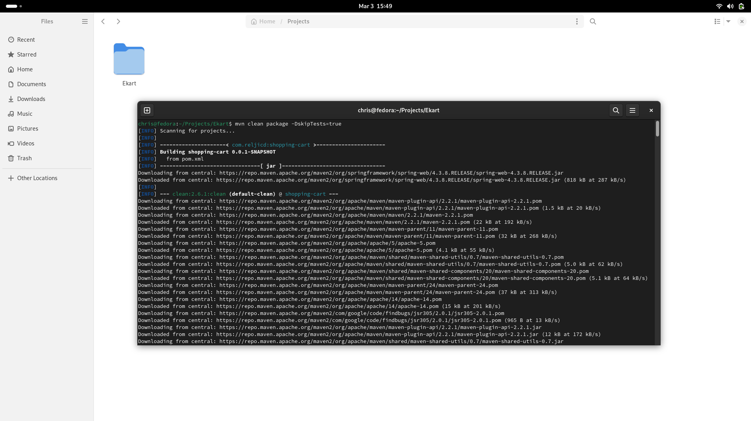

Now, Target folder has been created.

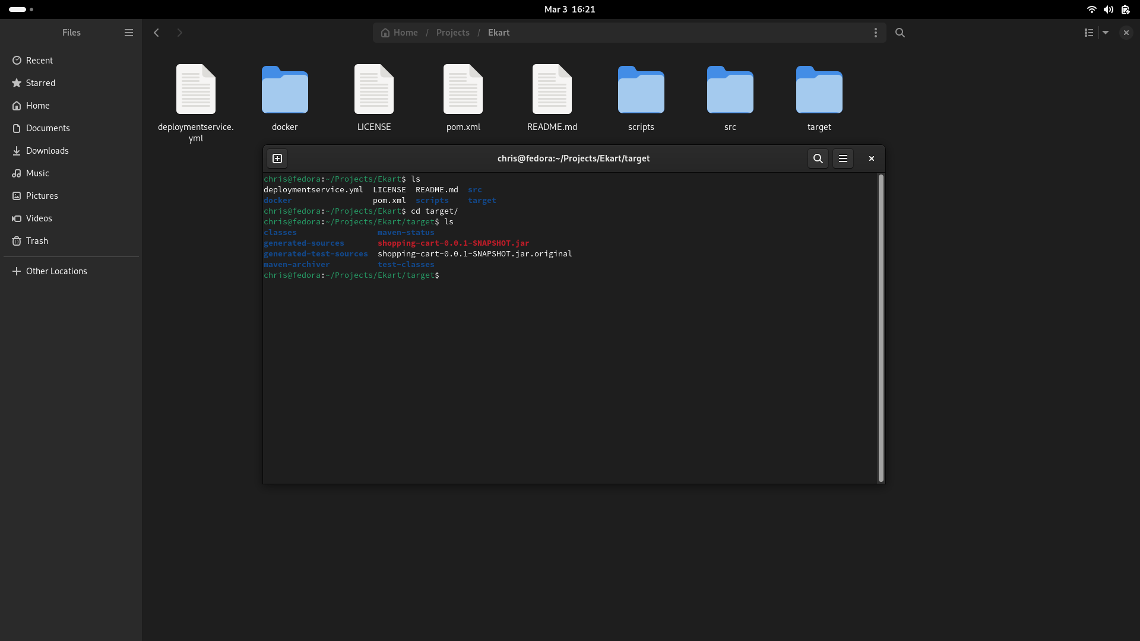

After that, Now we have to build our docker image using docker build command.

Cmd: docker build -t ekart:latest -f docker/Dockerfile .

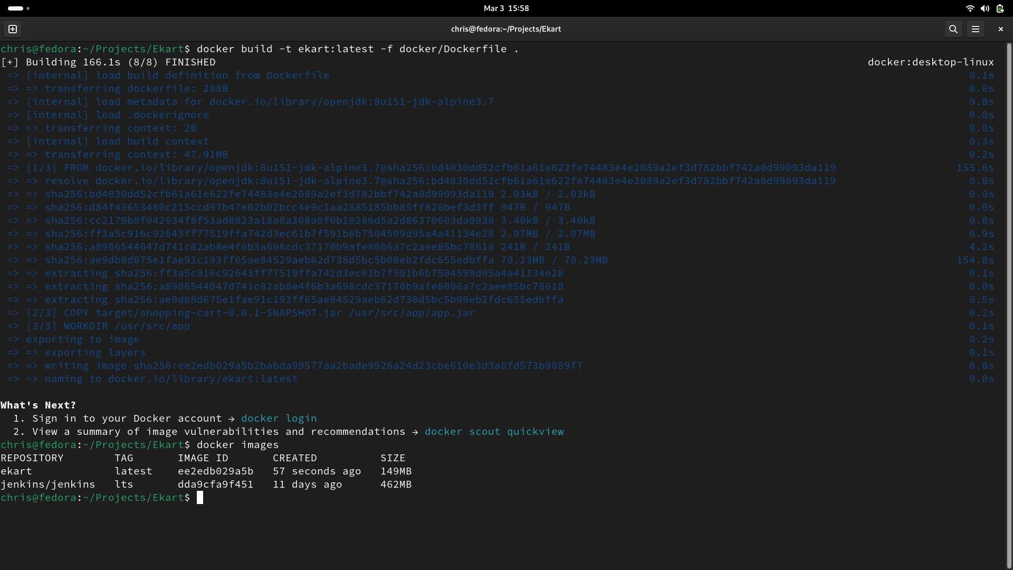

The docker image has been created.

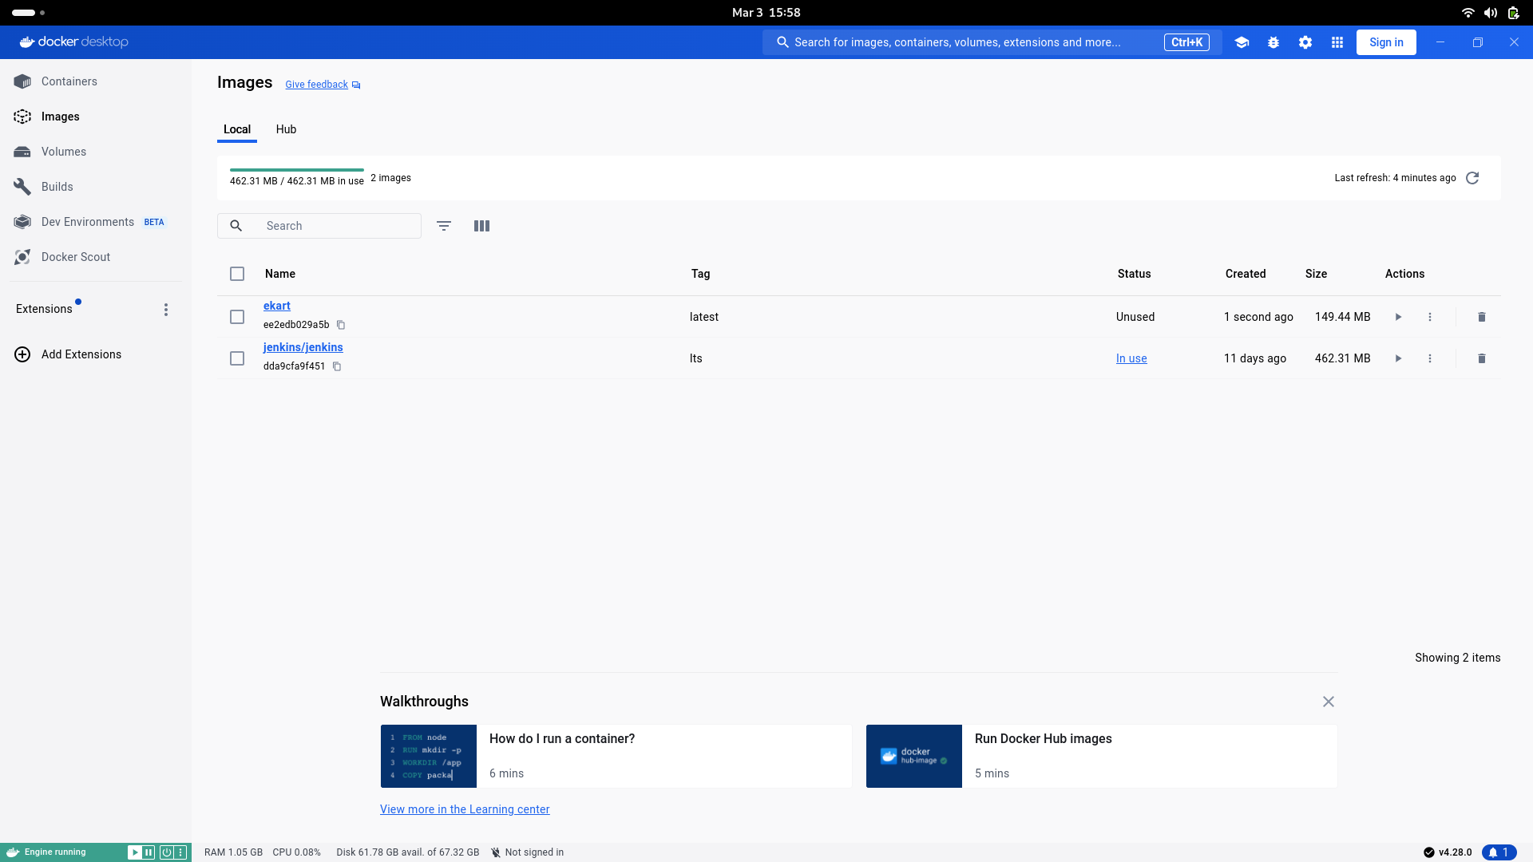

Docker image -> to show docker images in our pc



Now we have to run our docker container.

Cmd to run docker images:

docker run -d —name e-kart -p 8070:8070 ekart:latest

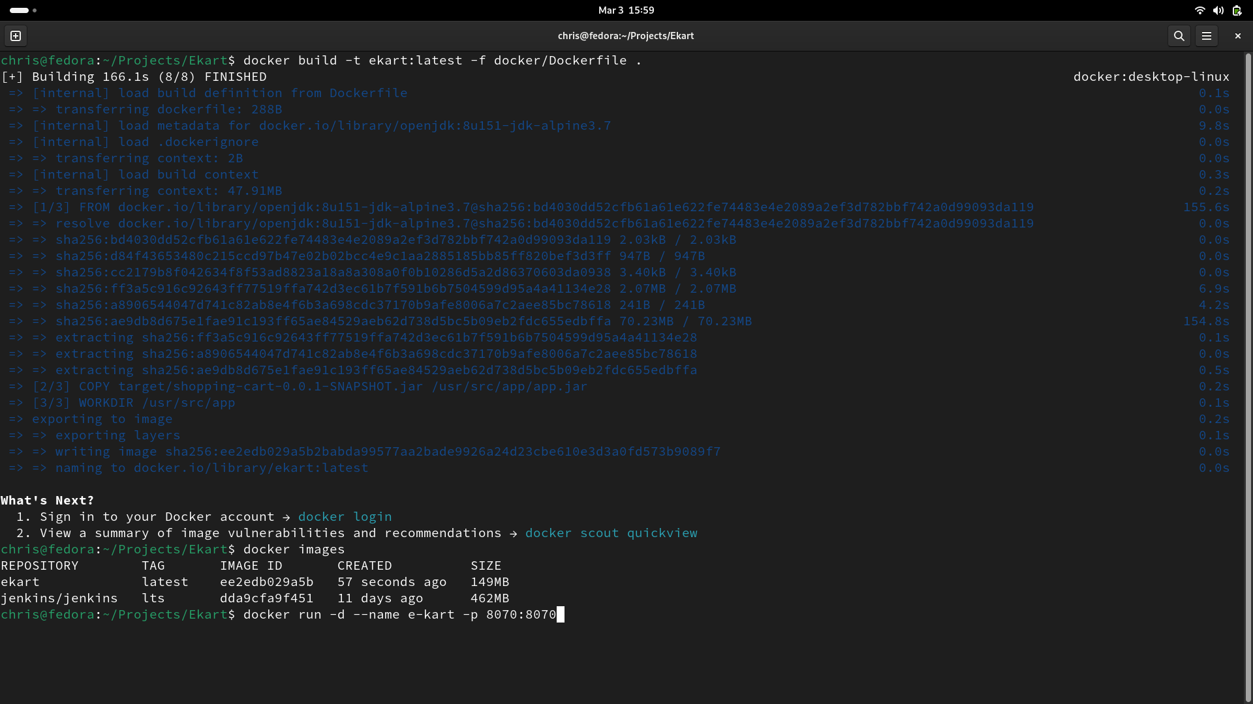

Now our docker image is running.

We can go to our browser and go to the 8070 port.

Localhost:8070 -> Our docker image is running in this port

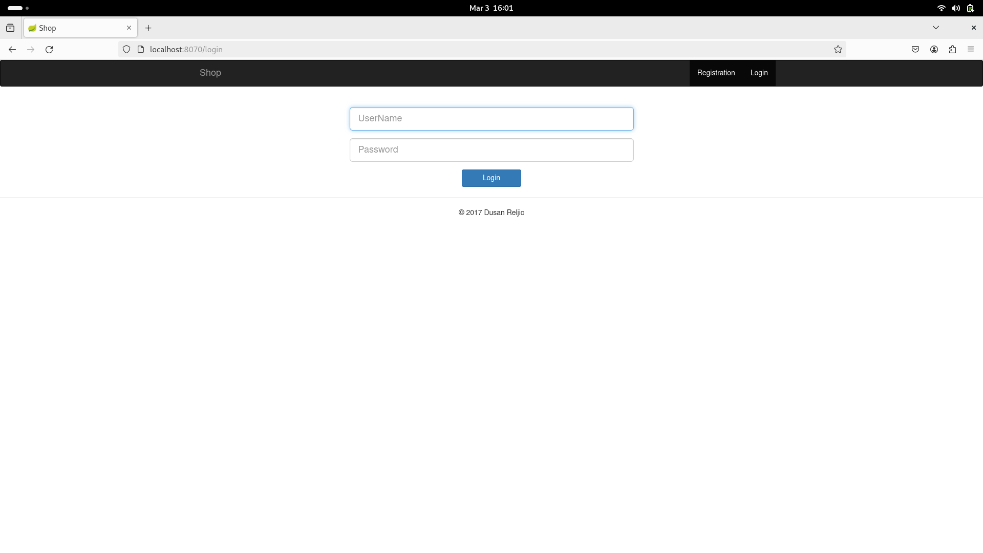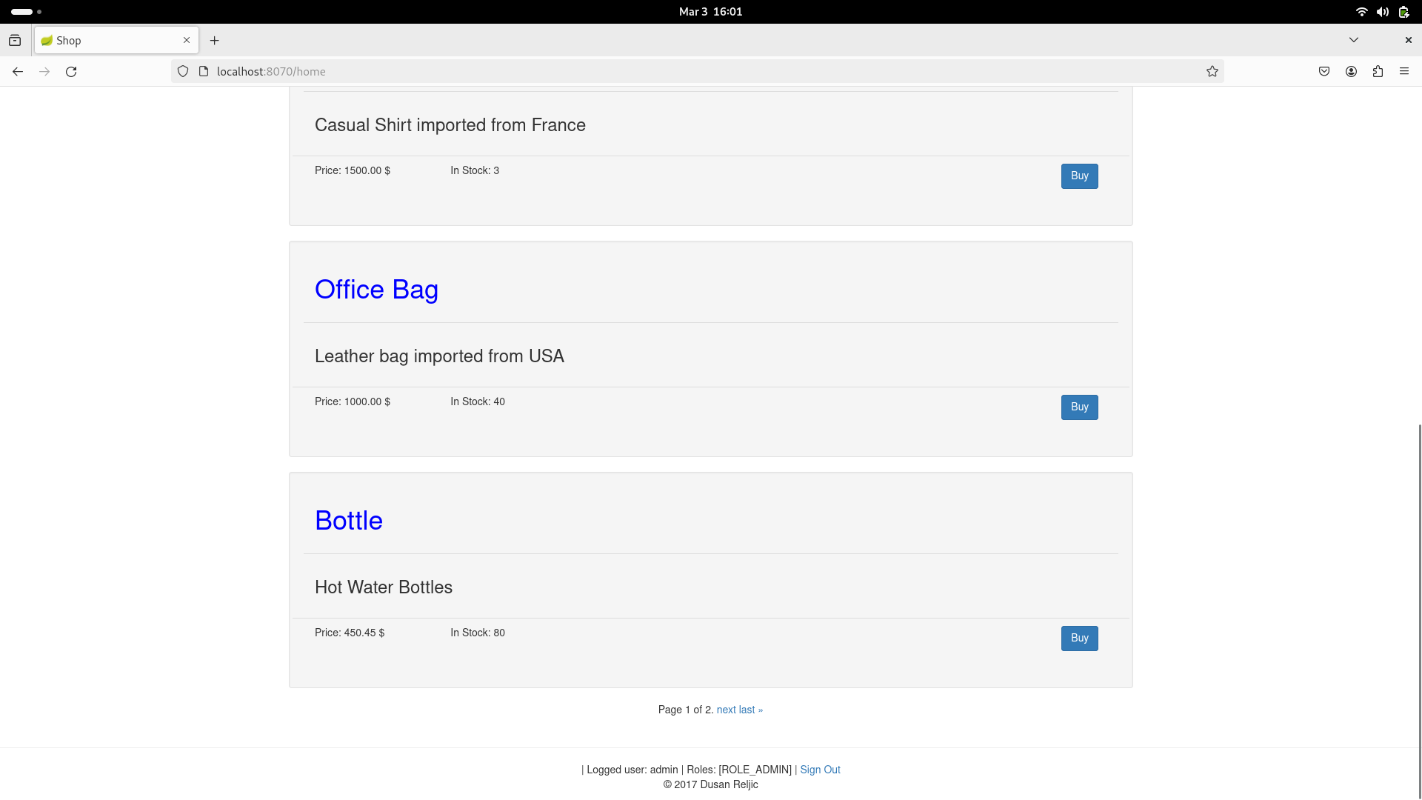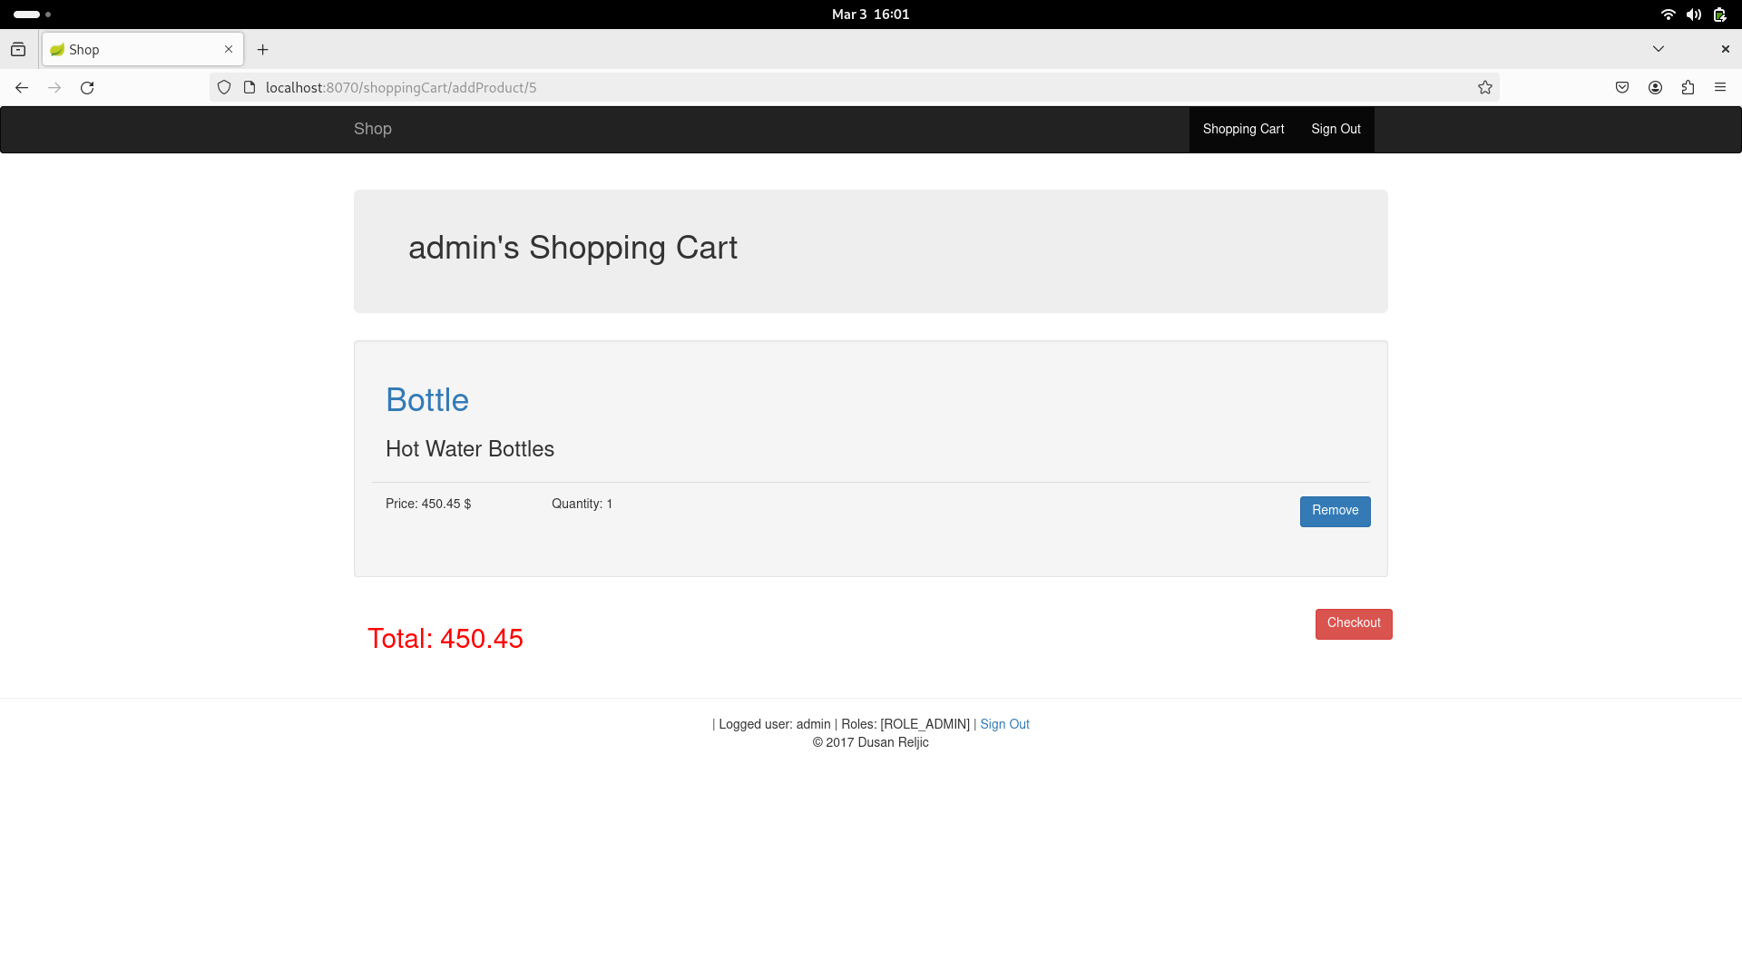

Now we had deployed full fledged application with docker container.